[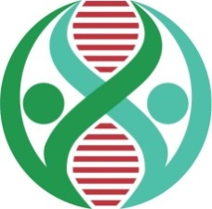](http://adnchacon.com/)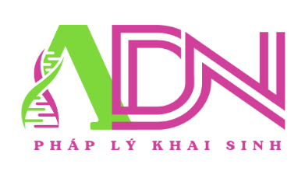[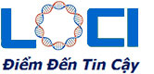](http://adnchacon.com/)



**KẾT QUẢ XÉT NGHIỆM ADN**

|  |  |  |  |  |
| --- | --- | --- | --- | --- |
| **HỌ TÊN**  **MÃ CODE** | **NEÀNG MA RA**  **V2456B** | | **CHAU ĐA RA**  **V2456D** | |
| **D3S1358** | **15** | **17** | **15** | **17** |
| **vWA** | **18** |  | **18** | **19** |
| **D16S539** | **9** | **11** | **9** | **10** |
| **CSF1PO** | **11** | **12** | **10** | **12** |
| **D6S1043** | **19** |  | **18** | **19** |
| **Yindel** |  |  | **1** |  |
| **AMEL** | **X** |  | **X** | **Y** |
| **D8S1179** | **10** | **11** | **11** | **13** |
| **D21S11** | **29** | **30** | **29** | **30.2** |
| **D18S51** | **15** | **16** | **13** | **16** |
| **D5S818** | **12** | **13** | **12** | **13** |
| **D2S441** | **11.3** | **12** | **10** | **11.3** |
| **D19S433** | **12** | **14** | **14** | **15** |
| **FGA** | **21** | **25** | **25** |  |
| **D10S1248** | **15** |  | **15** | **17** |
| **D22S1045** | **11** |  | **11** | **15** |
| **D1S1656** | **14** |  | **14** | **15** |
| **D13S317** | **8** | **11** | **8** | **11** |
| **D7S820** | **11** | **12** | **8** | **12** |
| **Penta E** | **11** | **17** | **11** | **17** |
| **Penta D** | **9** | **12** | **9** | **12** |
| **TH01** | **6** | **8** | **6** | **8** |
| **D12S391** | **19** |  | **19** | **24** |
| **D2S1338** | **17** | **20** | **19** | **20** |
| **TPOX** | **8** | **12** | **8** | **12** |

**(FORM KQ PHÁP LÝ CHUNG)**

**Kết luận: CÓ** quan hệ huyết thống, CON-CON ?**.**